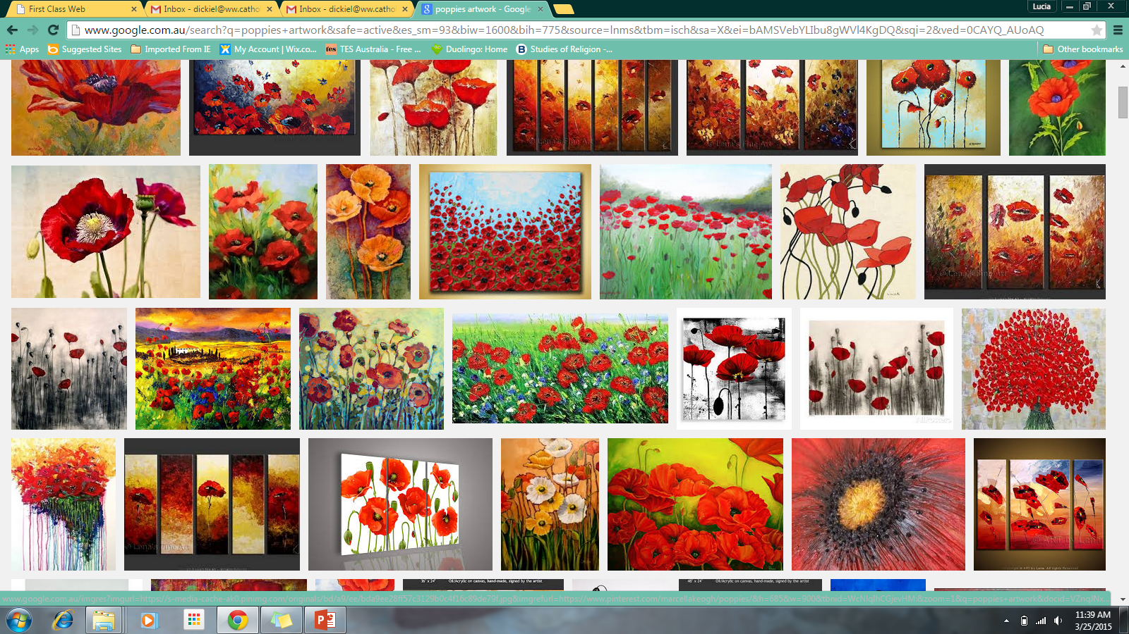POPPIES FOR GALLIPOLI- *YR 9 HOMEWORK TASK*