Creating Layers, Transparencies and using Brushes in Photoshop.

- Open Photoshop CS4
- Select File and New > Select International Paper from the preset menu and ensure it is set to A4 > Click OK
- To add a new layer for the colour background select Layer from the menu bar at the top of screen > New > Layer
- The box below will appear, name your layer ensure colour is None and click ok
- You have now created a transparent layer/ transparency.
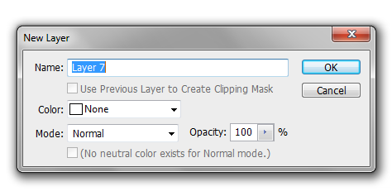

Add Colour

- Select the Gradient Tool > Paint Bucket Tool.
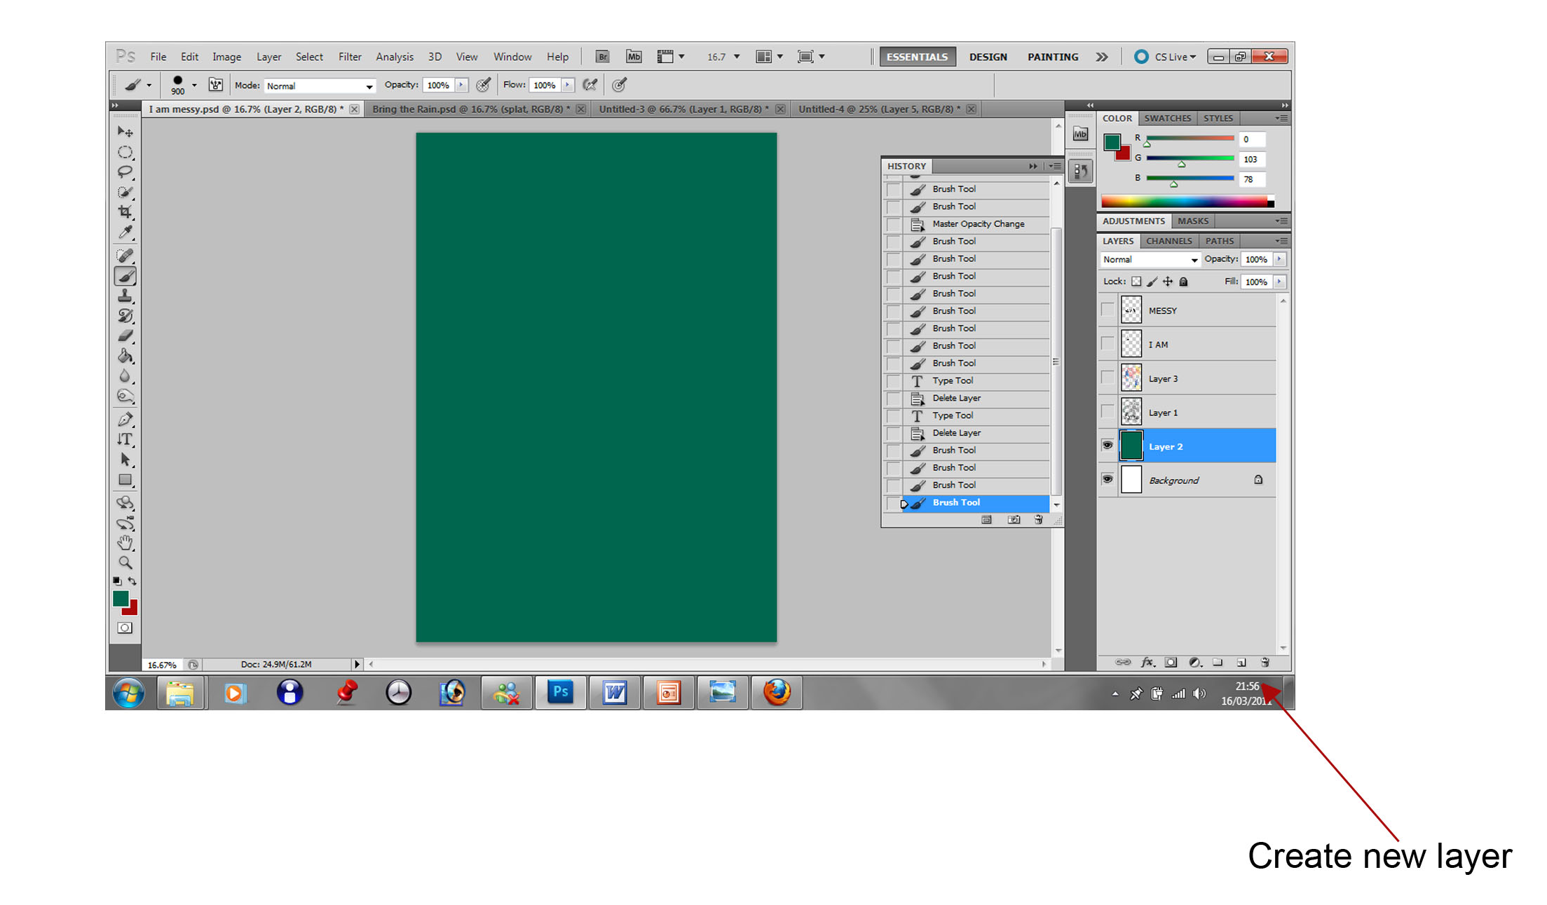
- To select your chosen colour double click the Palette Tool and select the colour of your choice. Add colour by clicking on your background image.
Quick Tip

To add new layers quickly select the new layer tool at the bottom of the layers menu to your right.

Gradient / Paint
Bucket Tool

Palette Tool

Opacity Setting

The Opacity setting in Photoshop can be used on each separate layer to make a layer more opaque or ‘See Through’. This can create great effects and make brush strokes or images appear lighter/more opaque in different layers.

Brush Tool

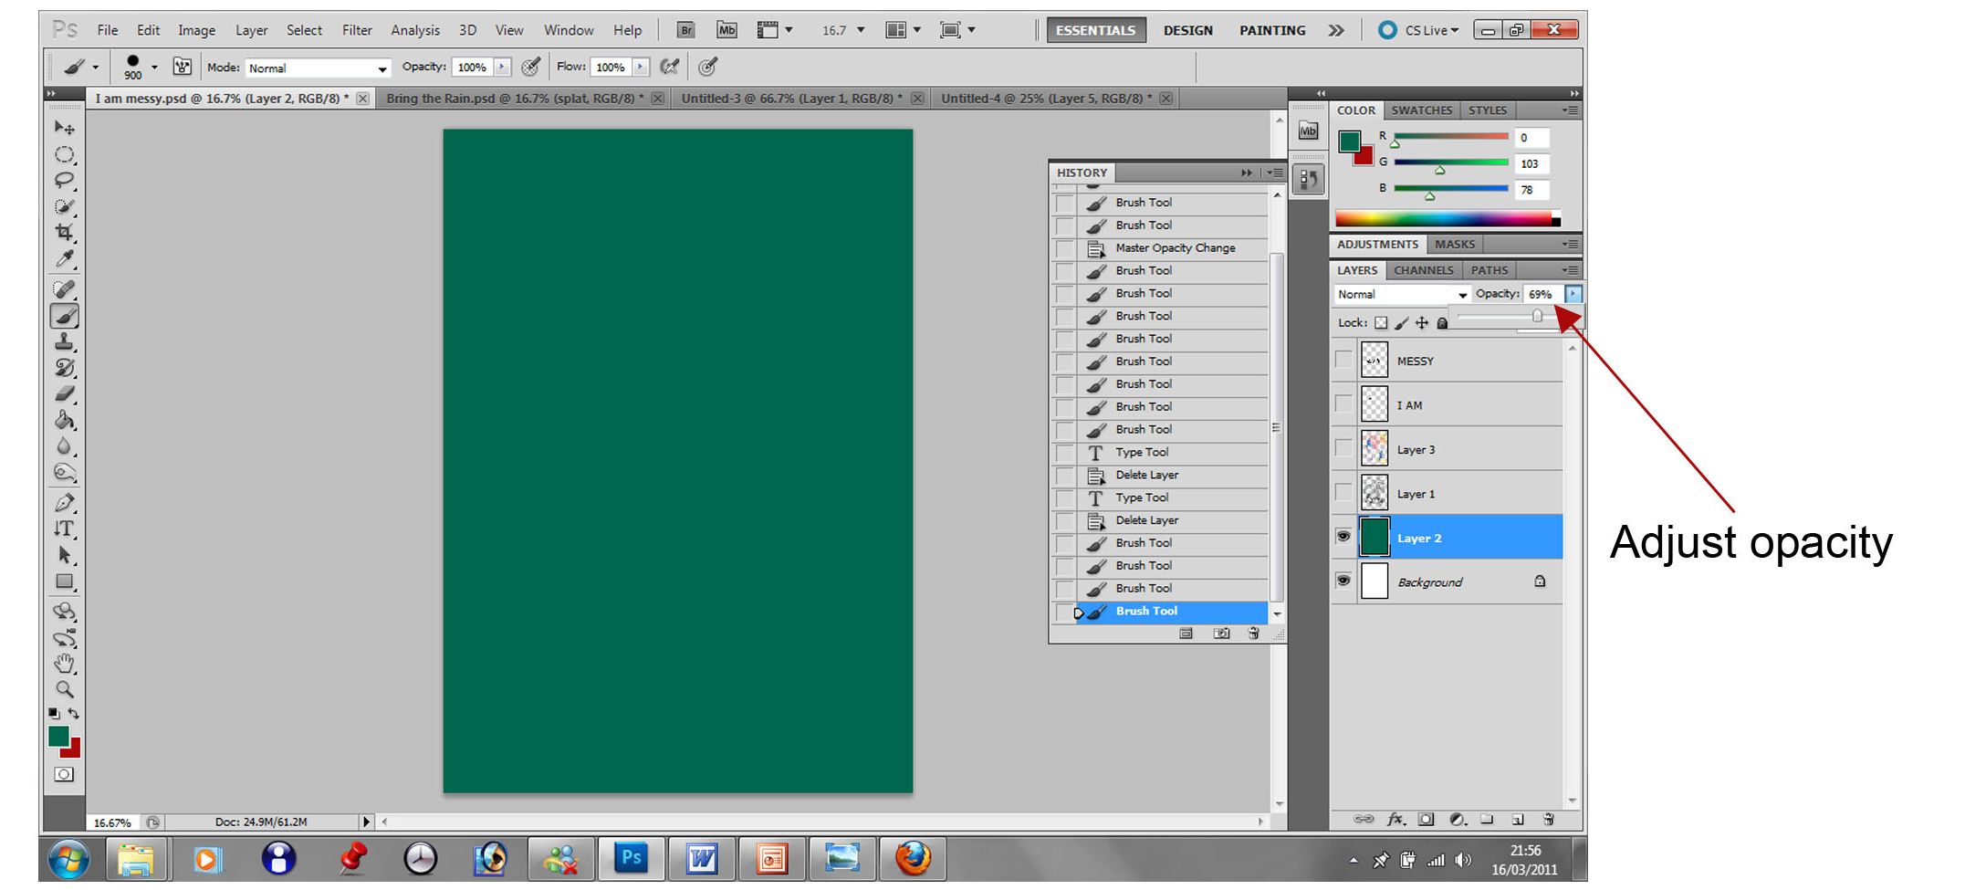
Using Brushes

- Using the short cut button on the layers palette create a New Layer
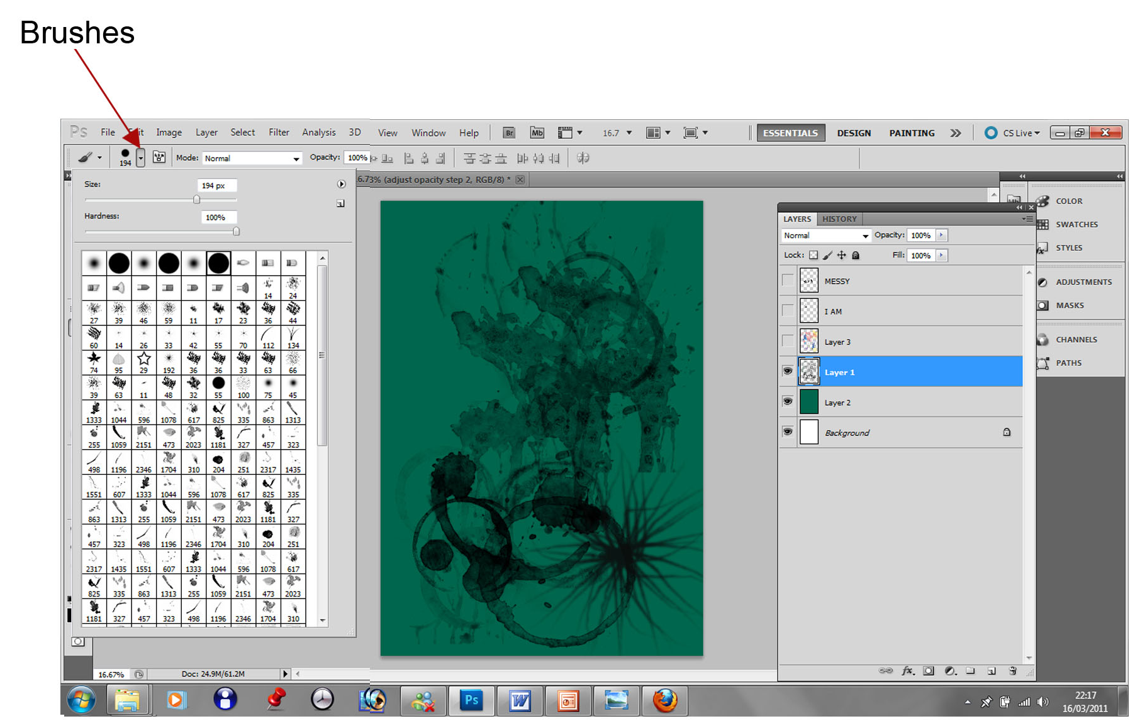
- Go to the tool Menu bar on the left hand side of the screen, select the Brush Tool > Select different brushes using the Brush Selection tool in the top menu bar.

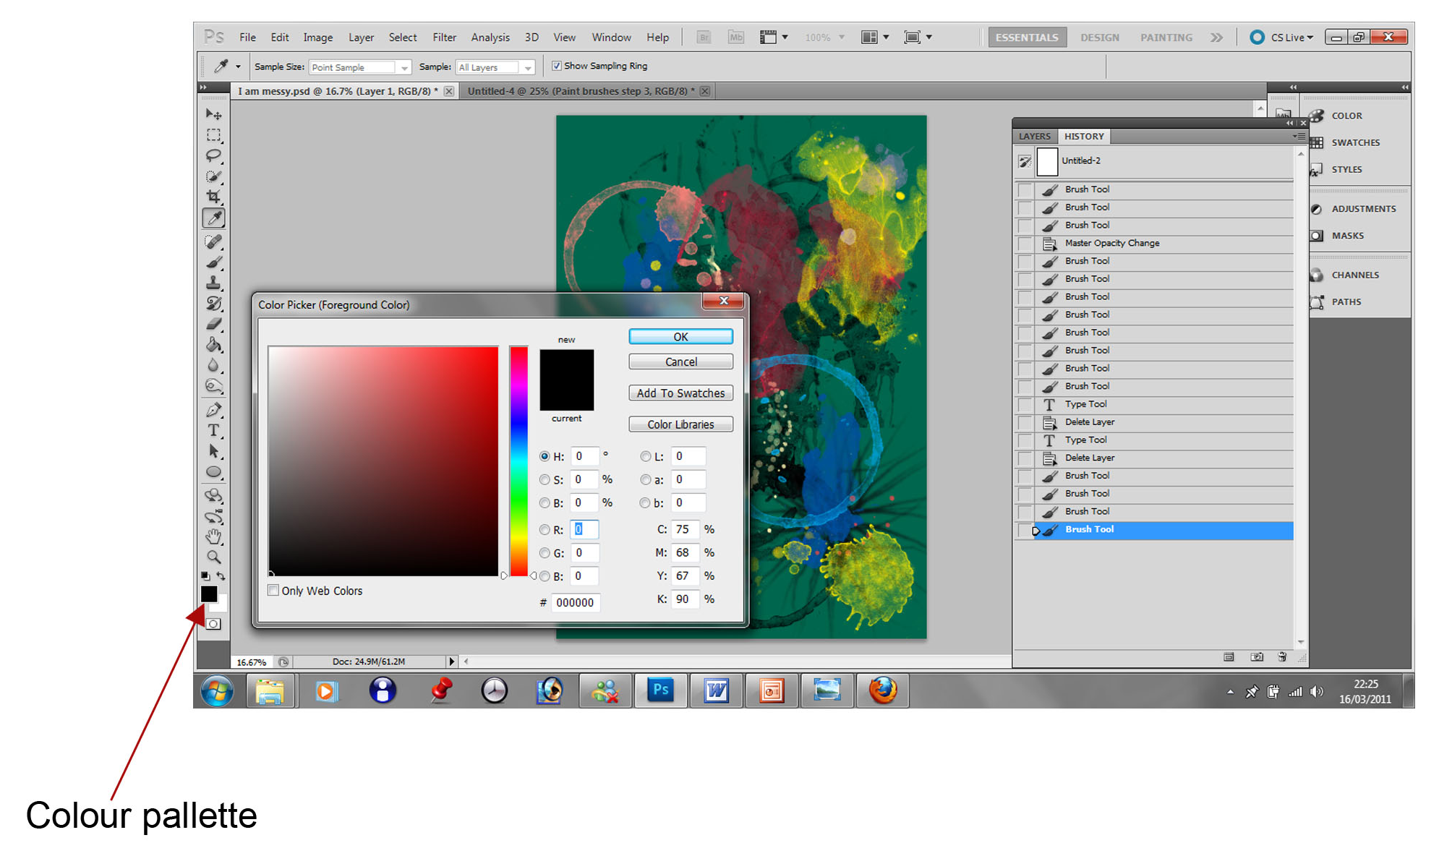
Keep experimenting with different Brushes and change the colour of your brushes using the Palette Tool, double clicking on the foreground colour. Build up your desired background pattern/image on as many layers as you need, perhaps adjusting the opacity of the top layer to allow a lower layer to show through.

Tool Menu Bar

Quick Tip

Quickly change the size of your brush using the bracket keys on your keyboard.

Adding Text

- To add your text select the Text tool in the Tool Menu Bar this will automatically create a new transparent layer.
- Select the font size and style that fits your word or statement.
- Write each word as a separate layer for more control over your image.
- To move your words around select the hand tool to place them in your desired position.
- To adjust any of your layers e.g. adding more brush marks, changing colours, opacity, font etc ensure the correct layer is highlighted in blue in the Layers List by clicking on the layer once.

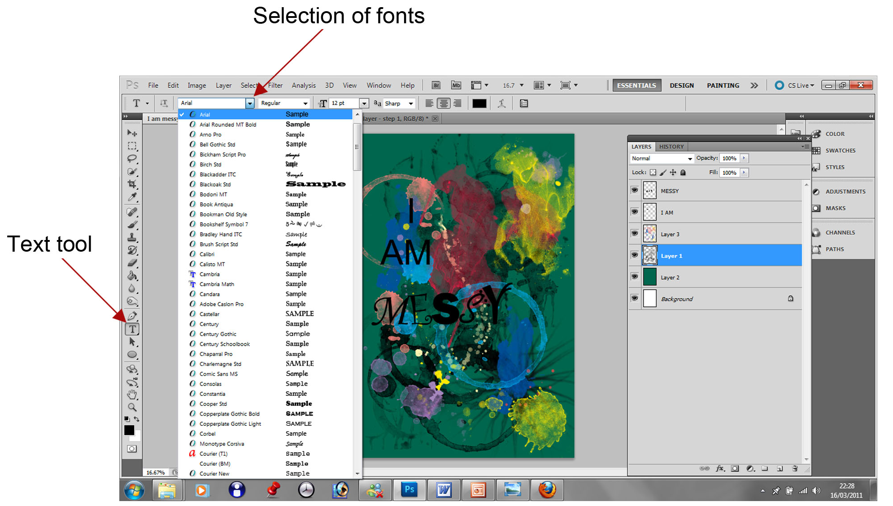

Layers List

Are you pleased with your outcome? What improvements could you make?

Ask the person next to you to tell you one thing they feel you have done well and if they could suggest one improvement to you for your final outcome.

