Pablo Picasso's 1914 "Guitar" Statue

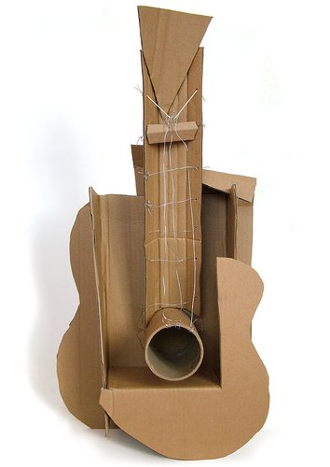Pablo Picasso is widely known as the father of cubism and the inventor of the collage. His artwork permanently altered the way the art world and the public alike define art, form, shape, and colour. Picasso was also one of the most prolific artists of the 20th century. His paintings, drawing, ceramics, and prints can be seen at many an art gallery. His sculptures, big and small, can be found all around the globe. His 1912/1914 "Guitar" sculpture is relatively small, especially when compared to some of his massive outdoor work, but it offers an excellent example of the assemblage technique for which Picasso became so widely recognized.

Picasso and Sculpture

Pablo Picasso is known as the founder of the Cubist movement. He is also credited with the invention of the concept of collage and constructed sculpture, or assemblage. He was one of the first to use plastics in his art. Picasso is credited with creating 1,228 sculptures over his long and prolific career. One of Picasso's most famous cubist sculptures is known as the "Chicago Picasso." The artist donated his 50-feet work to the people of Chicago in 1967.

Assemblage vs. Classical Sculpture

Before Picasso's revolutionary approach to sculpture, the art world had only ever been exposed to classical sculpture. Sculpture before the 20th century usually depicted the human form, or other objects from nature. Artists didn't see the relevance of sculpting manmade things, because you could simply make those objects. Why recreate something mankind already has complete control over creating? Sculpture was also executed by either carving, as in marble or stone, or molding clay or metal.  
Assemblage emerged in the 20th century as a way of creating sculpture by assembling found objects. These sculptures can take the form of both two-dimensional and three-dimensional pieces of art. Picasso was the father of this technique, though he was followed by many prolific artists who worked almost solely with the assemblage technique. Such artists include Jean Dubuffet, Marcel Duchamp, and Robert Rauschenberg.

Pablo Picasso produced an estimated total of 50,000 works of art, including 1,885 paintings, 1,228 sculptures, 2,880 ceramics, approximately 12,000 drawings, and thousands of prints, tapestries, and rugs.

Medium of "Guitar"

Picasso's first attempt at "Guitar" was made of cardboard, paper, and string in 1912. It was about 31x14 inches. Picasso recreated his original sculpture in 1914 with sheet metal and wire. The metal was cut, crimped, and folded to achieve the shape the artist desired. The metal version has the same dimensions as its cardboard predecessor. The use of these materials varied greatly from the traditional marble, wood, and bronze historically used for sculpture.

Public Reception

The first people to view "Guitar" were uncertain as to what they were actually looking at. It was unclear whether it was meant to be a sculpture or if it was a three-dimensional collage, for which Picasso had quite a reputation. Questions also arose concerning how to display the piece: on a wall, a pedestal, or hanging from the ceiling. Like much of Picasso's work, the skewed proportions of the object offer various ways of viewing the guitar. The point of view of the on-looker will determine the size, shape, and prominent features of the object, so that it will always look different depending on which side of the sculpture the viewer is standing.

Pablo Picasso's innovative work in assemblage sculpture shifted the way the art history world classifies sculpture in general. He revolutionized the form of classical sculpture by using a different medium and depicting manmade objects in addition to the more traditional natural subjects. His piece of art "Guitar" was one of the first examples of the fusion of collage and constructed sculpture to be seen in the art world. Through this piece of artwork, Picasso has offered the art-loving community a whole new way of approaching how we view and appreciate everyday objects.

Read Picasso's Guitar statue and write summary in VAPD.

DESIGN AND CONSTRUCT YOUR OWN CUBIST STYLE GUITAR (OR OTHER MUSICAL INSTRUMENT IF YOU WISH) FROM CARDBOARD AND STRING.

VIEW THE CLIP AT <http://www.youtube.com/watch?v=s0yQu2eDJQw>

TO GIVE YOU INSTRUCTIONS AND IDEAS.

DRAW A PLAN IN YOUR VAPD BEFORE YOU BEGIN CONSTRUCTION.