**Art & Ecology:**

**Perspectives and Issues**

http://greenmuseum.org/c/aen/Graphics/ruleorg.gif

**Ecological Restoration**

**Agnes Denes, *Wheatfield***

**by Don Krug**

[[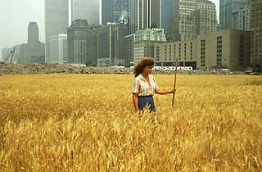](http://greenmuseum.org/c/aen/Images/Ecology/wheatfield.php)](http://greenmuseum.org/c/aen/Images/Ecology/wheatfield.php)

As early as 1968, Agnes Denes' work dealt with planting rice fields, creating time capsules, and chaining trees. Since 1965, Denes has been involved in more than 250 solo and group exhibitions. Her first major retrospective was held in 1994. She lectures frequently, participates in global conferences, and has received numerous awards. Denes' work is typically self-reflective. She states, "The issues touched on in my work range between individual creation and social consciousness. . . . Making art today is synonymous with assuming responsibilities for our fellow humans." (Oakes, 1995, p.166)

In some corners of the art world, Agnes Denes is probably best known for [*Wheatfield - A Confrontation, Battery Park Landfill, downtown Manhattan, 2 acres of wheat planted & harvested, summer 1982*](http://greenmuseum.org/c/aen/Images/Ecology/wheatfield.php). The *Wheatfield* project was a stark visual contradiction: a beautiful golden field of wheat set among the cool steel skyscrapers of downtown Manhattan. Denes believes her "decision to plant a wheatfield in Manhattan, instead of designing just another public sculpture, grew out of a long-standing concern and need to call attention to our misplaced priorities and deteriorating human values." (Oakes, 1995, p.168)

[[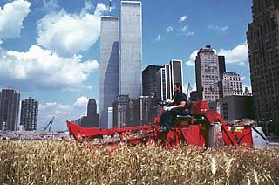](http://greenmuseum.org/c/aen/Images/Ecology/wheatfield.php)](http://greenmuseum.org/c/aen/Images/Ecology/wheatfield.php)

In, *Wheatfield - A Confrontation,* Denes examined the natural cycles of growth and regeneration. Her stated purpose was to call "people's attention to having to rethink their priorities." She constructed the wheatfield on a landfill near the World Trade Center, an unlikely spot for crop production. Two assistants and some volunteers helped her remove trash from the 4 acres of land, spread 225 truckloads of topsoil, and plant 1.8 acres of wheat. She contends the work would not have been possible without numerous volunteers who arrived at random to help, "ranging from one or two to six or seven on a good day". (Oakes, 1995, p. 169) An irrigation system was installed to sustain and regulate the wheat's growth cycle over four months. In summer, the green wheat stalks stretched skyward and turned a brilliant amber by early autumn. In the late fall, the artist harvested a thousand pounds of the grain. (Matilsky, 1992)

Matilsky (1992) writes

The project was an exuberant and daunting task celebrating the tenacity of life. By creating an art work with wheat, a grain planted throughout the world, Denes also called attention to hunger and the mismanagement of resources. Wheat was transformed into a symbol, as the artist's work highlighted incongruities. For example, the crop itself was located just a few blocks away from the New York Stock Exchange. The activities of the city and the countryside came together for a brief time. After harvesting, the hay was fed to the horses stabled by the New York City Police department and some of the grain traveled around the world in the exhibition **International Art Show for the End of World Hunger** organized by the Minnesota Museum of Art, 1987-90). The ecological cycle was thereby complete. (p. 51)

In retrospect, Denes believes that "*Wheatfield* affected many lives, and the ripples are extending. Reactions ranged from astonishment to tears . . . . After my harvest, the four-acre area facing New York Harbor was returned to construction to make room for a billion-dollar luxury complex. Manhattan closed itself once again to become a fortress, corrupt yet vulnerable. But I think this magnificent metropolis will remember a majestic, amber field." (Oakes, 1995, p.169) Denes thinks many New Yorkers became attached to the *Wheatfield* project. Some people wrote to ask her to continue the project.

[[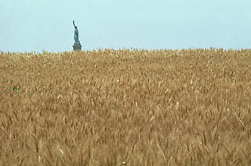](http://greenmuseum.org/c/aen/Images/Ecology/wheatfield.php)](http://greenmuseum.org/c/aen/Images/Ecology/wheatfield.php)

Another more permanent project by Denes is *Tree Mountain -A Living Time Capsule.* This work used mathematical applications to organize the planting of ten thousand trees by ten thousand different people. Denes (1995) said, "In 1982 I began work on *Tree Mountain*which is a collaborative, environmental project that touches on global, ecological, social and cultural issues . . . . *Tree Mountain* is designed to unite human intellect with the majesty of nature." (Oakes, p.170) The trees are planted in a spiral descending from the top of a gravel pit in the Finnish mountains. The artist believes the work is ". . . Finland's contribution to help alleviate the world's environmental stress. This will be the first time that an artist has been commissioned to restore environmental damage with an artwork that is global in scale, international in scope, and unsurpassed in duration." (Oakes, 1995, p. 171) Denes uses trees to signify community and to connect ideas about culture and nature. Creating ecological sustainability is an arduous task. Denes is committed to restoring healthy environmental systems through community dialogue and partnerships. Denes' work has become an important legacy for current contemporary ecological artists and will be for succeeding generations.

**Questions**

* How does the location of Agnes Denes' *Wheatfield, Battery Park City- A Confrontation* affect the meaning of the work? How would the meaning change if the work was produced somewhere else?
* Would the growth of other plants such as turnips, corn, or soybeans change the meaning of *Wheatfield, a Confrontation?*
* Describe Denes' use of symbolism in her choice of materials, and discuss how meanings become multilayered through the reinterpretation of them in different venues or exhibitions.
* Can short-term ecological community projects that take only a week, a month, or six months have long-term lasting effects on the ecological sustainability of a society?

**Resources**

Cembalest, R. (1991 Summer). "Ecological Art Explosion." *Art News,* 90(6), pp. 96-105.

Matilsky, B.C. (1992). *Fragile Ecologies: Contemporary Artists' Interpretations and Solutions.* New York: Rizzoli.

Oakes, B. (1995). *Sculpting with the environment--a natural dialogue.* New York: Van Nostrand Reinhold.