**Observational Drawing-Mixed Media Collage**

Objectives: Students will review drawing observation skills. Review how to judge angles of objects and the slants of the contour edges by using the sighting techniques. Learn the five elements of shading. Review the value scale & shading techniques with charcoal, pastels & drawing pencils.

**Value-** the lightness or darkness of a colour

**Chiaroscuro** is an Italian term that translates to mean light and dark. (chiaro, “light”, scuro, “dark”) Chiaroscuro specifically refers to a gradual transition of values used to achieve the illusion of how light and shadow interact on 3D forms (real objects.)

Leonardo da Vinci pioneered this technique during the Italian Renaissance in the late 15th century.

Early chiaroscuro drawings were done on toned paper, with one light chalk (such as white) and one dark chalk (such as dark red, sepia, or charcoal).

Many artists after Leonardo made effective use of this technique, but one of the most notable among them is Rembrandt.

**TIP:** You MUST know where your LIGHT SOURCE is coming from in order to shade effectively!

**[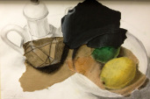](http://createartwithme.com/?attachment_id=1345)[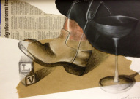](http://createartwithme.com/?attachment_id=1347)[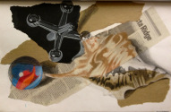](http://createartwithme.com/?attachment_id=1348)BELOW ARE SOME EXAMPLES OF STILL LIFE MIXED MEDIA DRAWINGS**

[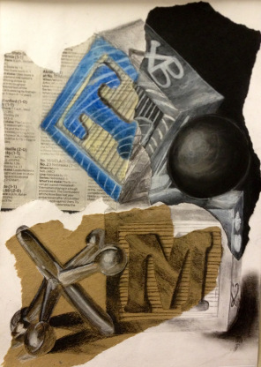](http://createartwithme.com/?attachment_id=1350)[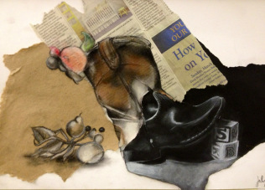](http://createartwithme.com/?attachment_id=1346)[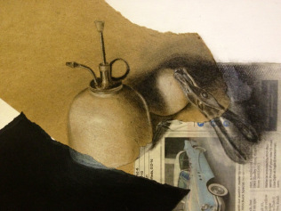](http://createartwithme.com/?attachment_id=1343)

**Mixed-Media Drawing & Collage Project**

Project Objective: Create a mixed media realistic drawing of a group of 3-4 objects with FULL shading. Use good drawing observation skills to draw the still life accurately then render with FULL shading using the designated media below. Include all 5 Elements of Shading where applicable.

Mixed-media mediums to include:

Pastels or Coloured Pencils on Newspaper

Charcoal & white charcoal on Brown Paper

White Charcoal on Black Paper

Drawing Pencils on White Paper

**Instructions:**

Prepare surface one class in advance: students collage a scrap of newspaper, a piece of black charcoal paper, and a scrap of brown craft paper onto an A3 white sheet of drawing paper.

Choose 3-4 objects to draw from the still life boxes. No more than two can be fruit (only 1 simple fruit), the rest must be objects. Arrange the still life in an interesting composition on white paper.

Use your phone or computer to take pictures of the composition. Crop in closely to the arrangement & make sure we can see highlights & shadows.

Draw out your composition onto your prepared paper using a lead pencil. Draw it so that it crosses over all of the different papers-make it go off the page if you have to. Make sure your drawing is as accurate as you can draw!

In each of the different papers, use the designated mediums to render the drawing with FULL shading.

When completely finished, LIGHTLY spray drawing with hair spray to “fix” the charcoal & pastels to the paper.

Materials: Still life objects, newspaper, colored pencils, black & [Compressed Charcoal Sticks 4/Pkg-White – Soft Assorted](http://www.amazon.com/gp/product/B004M54ZL4/ref=as_li_ss_tl?ie=UTF8&camp=1789&creative=390957&creativeASIN=B004M54ZL4&linkCode=as2&tag=crarwime-20)http://ir-na.amazon-adsystem.com/e/ir?t=crarwime-20&l=as2&o=1&a=B004M54ZL4and pencils, brown wrapping paper, [Reeves Assorted Soft Pastel Set 36-Pack](http://www.amazon.com/gp/product/B000UNRNXY/ref=as_li_ss_tl?ie=UTF8&camp=1789&creative=390957&creativeASIN=B000UNRNXY&linkCode=as2&tag=crarwime-20)http://ir-na.amazon-adsystem.com/e/ir?t=crarwime-20&l=as2&o=1&a=B000UNRNXY, [Semi-Hex Graphite Drawing Pencils 4/Pkg-HB, 2B, 4B, & 6B](http://www.amazon.com/gp/product/B000UZRTPE/ref=as_li_ss_tl?ie=UTF8&camp=1789&creative=390957&creativeASIN=B000UZRTPE&linkCode=as2&tag=crarwime-20)http://ir-na.amazon-adsystem.com/e/ir?t=crarwime-20&l=as2&o=1&a=B000UZRTPE, black charcoal paper, glue sticks, 12×18 or 18×24″ white drawing paper, [Stumps And Tortillions Set](http://www.amazon.com/gp/product/B002ER8M0C/ref=as_li_ss_tl?ie=UTF8&camp=1789&creative=390957&creativeASIN=B002ER8M0C&linkCode=as2&tag=crarwime-20)http://ir-na.amazon-adsystem.com/e/ir?t=crarwime-20&l=as2&o=1&a=B002ER8M0C