**Jan Van Eyck and the Arnolfini Wedding Portrait**

[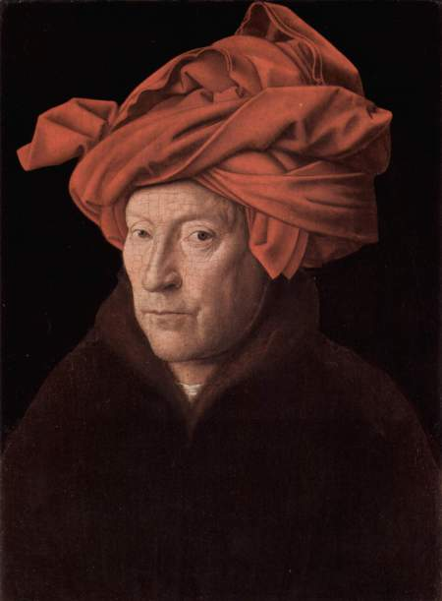](http://artchronicler.files.wordpress.com/2010/02/jan-van-eyck4.jpg)           Jan Van Eyck (1390/95-1441) was born in the town of Maaseik in the Province of Limburg, located along the border of modern day Belgium, and the Netherlands.  He was the sibling of painters Hubert Van Eyck (1385/90-1426) and Margaret Van Eyck.  Van Eyck was appointed court painter by John of Bavaria, the Count of Holland in The Hague, in 1422. After the Count’s death, in 1425, he became the painter and *valet de chambre* to Philip the Good, Duke of Burgundy and the grandson of Philip the Bold. He traveled to Italy in 1425, and was part of a delegation that was sent by Philip the Good to Portugal in 1428 to negotiate an offer of marriage between Philip and Isabella, daughter of King John I of Portugal.  He settled in Bruges in 1431, and lived their until his death (Scallen 18).

            Van Eyck painted during the Northern Renaissance, a period of great prosperity for Burgundy (modern day Belgium and the Netherlands).  Burgundy’s location made it ideal as a center for trade and banking.  This prosperity increased the wealth of the middle class, broadened the patronage of the arts, and increased the social status of artists.  Merchants and bankers commissioned a portion of Van Eyck’s artwork (Kloss 94).

          The term renaissance typically refers to a renewed interest in the classical arts and culture of Rome and Greece as in the Italian Renaissance.  However, the Northern Renaissance was characterized more by “… an interest in the observable physical appearance of the world and the place of humans in that world.  This, rather than stylistic considerations or an interest in antiquity, is what justifies speaking of a Northern Renaissance” (Kloss 94-95).

[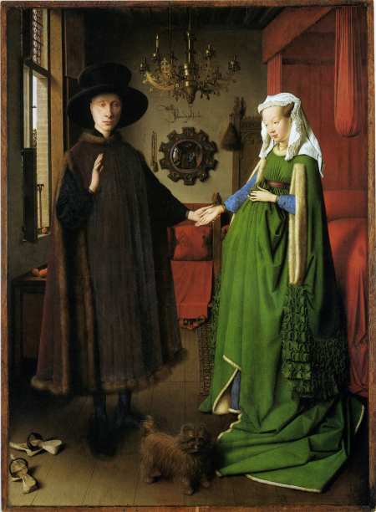](http://artchronicler.files.wordpress.com/2010/02/arnolfini-wedding1.jpg)            Van Eyck used oil-based paint as the medium for his artwork.  This type of paint is manufactured by adding pigment to linseed or walnut oil.  Oil based paint dries slowly allowing the painter more time to make revisions and to add detail, and it has a luminous quality that allows the artist “to capture rich jewel-like colors and subtle changes in textures and surfaces” (Stokstad 596).  Van Eyck was not the inventor of oil-based paint, but he is recognized as being one of the first to perfect its use (Kloss 95).

            One of Van Eyck’s greatest masterpieces is the *Arnolfini Wedding Portrait*, (1434, Oil on Panel, 32 ¼” x 23 ½’, National Gallery, London).  The Painting is of a man and a women standing together in front of a bed.  The man has traditionally been identified as the Italian merchant, Giovanni Arnolfini and his wife, Giovanna Cenami, but this has not been confirmed (Scallen 29).  “The room is a lit by a window at the left; light glides across the back wall to the bed at right, and the couple is lit by an unseen source” (Kloss 95).  Traditionally, it is believed that the scene is a private wedding ceremony, and the painting acts as a marriage certificate; but it has also been suggested that the painting celebrates the continuity of their married life, or the close relationship between the couple.

[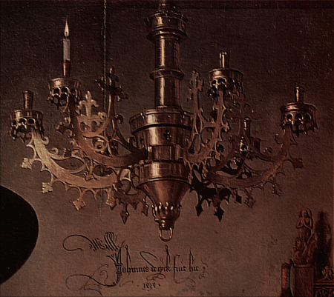](http://artchronicler.files.wordpress.com/2010/02/arnolfini-wedding-chandelier.jpg)          “Whatever event or situation the painting depicts, the artist has juxtaposed secular and religious themes in a work that seems to have several levels of meaning” (Stokstad 600) including:

* The chandelier has one lit candle signifying matrimony and the unity of marriage (Stokstad 600);

[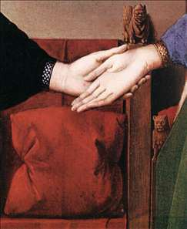](http://artchronicler.files.wordpress.com/2010/02/arnolfini-wedding-hands.jpg)

* The man uses his left hand to support but does not grasp the women’s hand.  He holds his right hand up as if he is taking an oath (Kloss 95);
* The removed shoes suggest sanctity (Crenshaw 29);

* [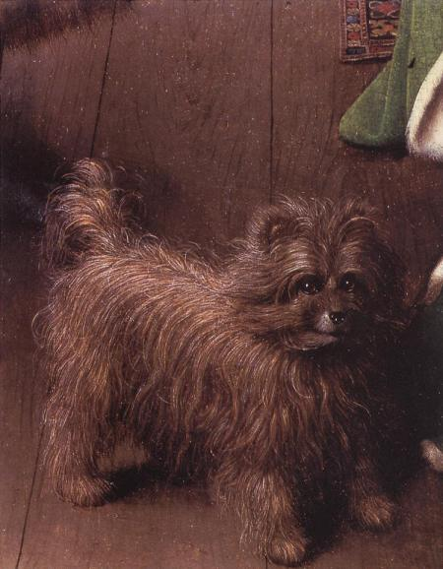](http://artchronicler.files.wordpress.com/2010/02/arnolfini-wedding-dog.jpg)“The small dog may simply be a pet, but it serves also as a symbol of fidelity, and its rare breed – affenpinscher – suggest[s] wealth (Stokstad 600);

* The spotless convex mirror on the back wall alludes to purity, and the reflection of two other individuals in the room (including the painter) infers that witnesses are present (Kloss 95);

* [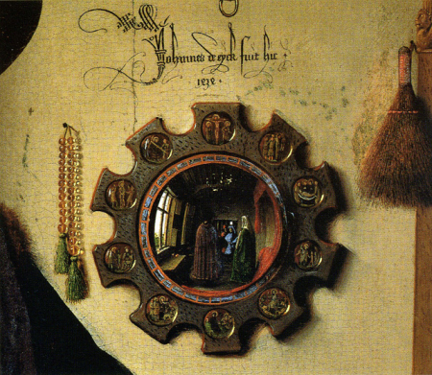](http://artchronicler.files.wordpress.com/2010/02/arnolfini-wedding-mirror.jpg)The inscription on the back wall translates “Jan Van Eyck was here, 1434” suggests that the artist was a witness to the wedding (Stokstad 600);

* “…the crystal prayer beads on the wall [and] the image of Saint Margaret protector of women in childbirth, carved on the top of a high-backed chair next to a bed … suggest the piety of the couple” (Stokstad 600); and

* [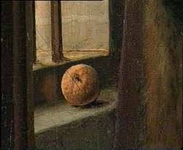](http://artchronicler.files.wordpress.com/2010/02/arnolfini-wedding-orange.jpg)Oranges on the windowsill indicates innocence before Adam and Eve’s fall from grace, and the couple’s wealth (Stokstad 600).

             Van Eyck’s technique and attention to detail makes the painting a beautiful piece of art, but it is his ability to inject such great symbolism that makes it a masterpiece.  “This unusual, innovative, and still captivating painting makes us believe in the world the painter has created as plausible.  Whatever, the patrons and Van Eyck had in mind, they have become immortal trough art” Scallen 30).

**Works Cited**

Chatelet, Albert. *Van Eyck*. Trans. Murtha Baca. 1979. Woodbury: Barron’s, 1980. Print.

Crenshaw, Paul, Rebecca Tucker, and Alexandra Bonfante-Warren.*Discovering the Great Masters – the Art LoVan Eyckr’s Guide to Understanding Symbols in Paintings*. New York: UniVan Eyckrse, 2009. Print.

Dhanens, Elisabeth. *Van Eyck: The Ghent Alterpiece*. Ed. John Fleming and Hugh Honour. New York: Viking, 1973. Print.

Fiero, Gloria K. *Landmarks in Humanities*. 2nd ed. 2006. New York: McGraw Hill, 2009. Print.

Graham, Jenny. *InVan Eycknting Van Eyck the Remaking of an Artist for the Modern Age*. New York: Berg, 2007. Print.

Hall, Edwin. *The Arnolfini Betrothal – Medieval Marriage and the Enigma of Van Eyck’s Double Portrait*. Berkeley: UniVan Eyckrsity of California, 1997. Print.

Kloss, William. *A History of European Art*. Chantilly: Teaching, 2005. Print.

Philip, Lotte Brand. *The Ghent Alterpiece and the Art of Jan Van Eyck*. Princeton: Princeton UniVan Eyckrsity, 1971. Print.

Scallen, Catherine B. *The Art of the Northern Renaissance*. Chantilly: Teaching, 2005. Print.

Stokstad, Marilyn. *Art History*. Ed. Sarah Touborg. 3rd ed. Upper Saddle RiVan Eyckr: Person Prentice Hall, 2008. Print.