**YEAR 9 VISUAL ARTS VOCABULARY TASK**

*Match the term with the meaning and the example. Arrange them under the heading ‘Cubist art terms’ then print and glue into your VAPD*

**Found object abstract geometric abstraction**

**faceted surfaces multiple views spatial ambiguity**

a form of abstract art based on the use of geometric forms Can be found in many High Analytic Cubist artworks

Simultaneity depicts more than one view of an object on one plane. Pablo Picasso's Still Life with Compote and Glass (1914-15), where we see the circular mouth of the glass attached to its distinctive fluted goblet shape. One area connects two different planes (top and side) Another shows different views of the glass (top and side).

small plane surfaces -like the many surfaces of a cut gemstone

The shape and geometry of a region within an image An illusion that is neither flat nor volumetric. It is a form of optical illusion whose interpretation is left to the eyes of the viewer.

An existing 2d or 3d object not created as art that is taken to be used in an artwork. Many artists have worked with recycled materials, rubbish, dolls etc

nonfigurative art, non-objective art, and nonrepresentational art

[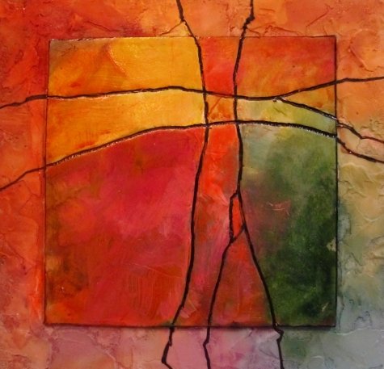](http://www.google.com.au/url?sa=i&rct=j&q=abstract+art&source=images&cd=&cad=rja&uact=8&docid=OUqfM2U2hQ1HQM&tbnid=BotYcw3Wa1M5fM:&ved=0CAUQjRw&url=http://abstractartpictureswallpaper.blogspot.com/2013/04/abstract-art-definition-pictures.html&ei=gKmCU86rIIHs8AXVx4G4Aw&bvm=bv.67720277,d.dGc&psig=AFQjCNHySZxwa_iVXVi8tHqnNM2I3Mi6RQ&ust=1401158322373962)[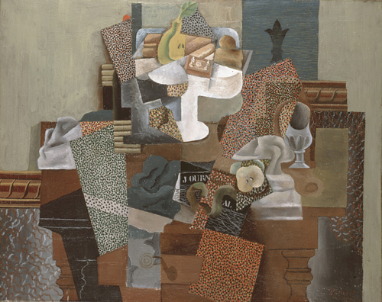](http://0.tqn.com/d/arthistory/1/0/6/p/cab_pma_09_15.jpg)

[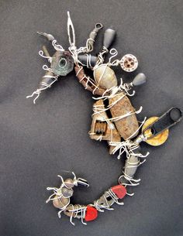](http://www.google.com.au/url?sa=i&rct=j&q=found%20object%20artwork&source=images&cd=&cad=rja&uact=8&docid=57NH6HhnGUnAdM&tbnid=Jlkki-zPPDHTLM:&ved=0CAUQjRw&url=http://www.pinterest.com/h1d3ns33k/found-object-art/&ei=MayCU5SCJ9P28QXV7gE&psig=AFQjCNHnMev61uZf87nGfoF2co_JSKw1QQ&ust=1401159023666258)[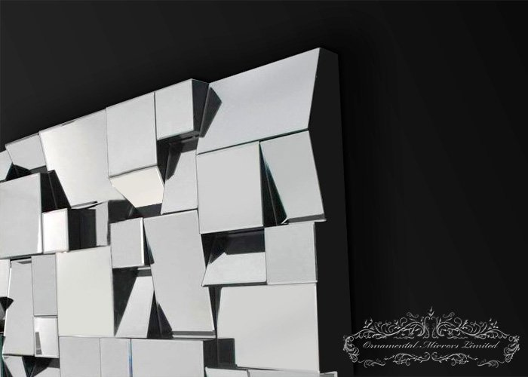](http://www.google.com.au/url?sa=i&rct=j&q=multi+faceted+artwork&source=images&cd=&cad=rja&uact=8&docid=Ys82dZ7NojZpQM&tbnid=u9GoOG-04zyeYM:&ved=0CAUQjRw&url=http://www.ornamentalmirrors.co.uk/mirrors/fracture-multi-facet-mirror&ei=36qCU8qYCdSE8gWLxYCgBg&bvm=bv.67720277,d.dGc&psig=AFQjCNHhUNYh9Q414OVn4LYs4Jh5TdDpqw&ust=1401158733732533)

[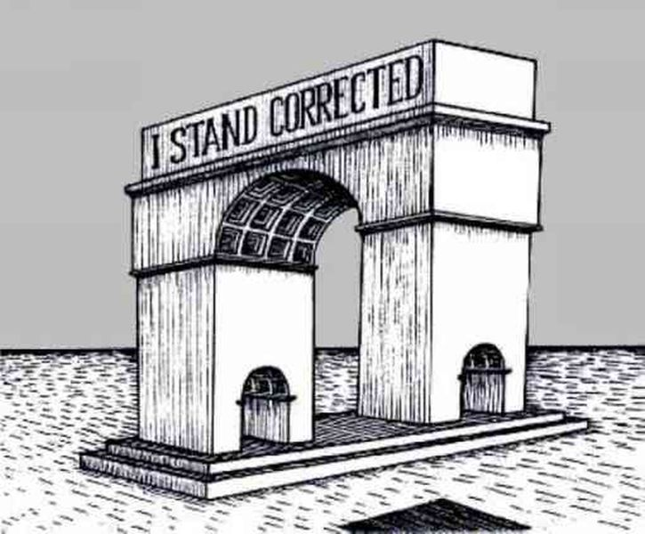](http://www.google.com.au/url?sa=i&rct=j&q=spatial%20ambiguity%20in%20artwork&source=images&cd=&cad=rja&uact=8&docid=AkHRgqWyPk1JPM&tbnid=V7z9iW6X2oQfJM:&ved=0CAUQjRw&url=http://brainden.com/impossible-objects.htm&ei=l62CU9CFD4KF8gXCrIGICw&psig=AFQjCNG9-a-UAVf34V5gcViUQJ0ehPfCUA&ust=1401159395231389)

[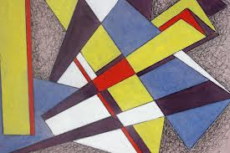](http://www.google.com.au/imgres?imgurl=http://images.artnet.com/aoa_lot_images/81095/thomas-brownell-eldred-untitled-geometric-abstraction-works-on-paper-drawings-watercolors-etc-gouache-ink-zoom-3.JPG&imgrefurl=http://www.artnet.com/auctions/artists/thomas-brownell-eldred/untitled-geometric-abstraction-6&h=3168&w=4752&tbnid=hVBT_r5WHIZ1fM:&zoom=1&q=geometric%20abstraction%20in%20artwork&docid=nBo-jeoL7mOn_M&ei=2a2CU-P3GZW68gXZoYLwDg&tbm=isch&ved=0CJsBEDMoQTBB&iact=rc&uact=3&dur=408&page=3&start=46&ndsp=25)